Промежуточная контрольная по английскому языку.
7 класс (углубленный уровень)

№1 Complete the sentences with the correct word:
curious, dangerous, lighting, soothe, bark, look after, slippery, cheerful, lawyer, concentrate, gossip, footpath, champion, special offer.

- Sam is very……………………. and always asks lots of questions
- Drive carefully! The roads are really ……………………………….after last night’s rain.
- The robber refused to answer the policeman’s questions until his ………………………………..arrived.
- He was sentenced to two years in prison for………………………… driving.
- My friend gave up a great job to …………………………..homeless people.
- Follow the ………………………………..that leads up to the top of the hill.
- The………………………..made the whole theatre look red and gold.
- I couldn’t …………………………………….at work today because I didn’t get enough sleep last night.
- Kate is always so……………………………... She’s always smiling and I’ve never seen her In a bad mood!
- He’s world for the third time.
- Cold water will …………………………the pain if you burn your hand.
- There’s a ………………………………at the hotel at the moment – 4 nights for the price of 2.
- It’s annoying when people ……………………………………..about me.
- Our neighbours let their dog …………………………….all night.

№2 Underline the correct variant:
- Dan is going/goes a job interview tomorrow.
- Patricia is wanting/wants to buy some old coins.
- Dean doesn’t believe/ isn’t believing in ghosts.
- She’s looking forward to going/ to go to university.
- Peter has difficulty finding/to find an evening job
- Gary was writing postcards while Laura was taking/ took photos.
- We were watching/ watched a film at 9 o’clock yesterday evening.
- Susan opened the door and was running/ran out of the house.
- He had been walking/ had walked for an hour before he reached the cabin.
- She was tired because she hadn’t been sleeping/ hadn’t slept the previous night.
- I promise I will go/ is going on holiday with you next year.
- Dan will meet/ is meeting his friends in the park in half an hour.
- I will do/ am going to do yoga on the beach when I’m on holiday next month.
- When the weather gets warmer, ice will melt/ melts.
- Unless you go to the USA, you won’t be able/ are able to go surfing.
- If I would be/ were you, I’d go to Chile this year.
- If you had been more careful, you wouldn’t have hurt/ wouldn’t hurt yourself.
- Max was ill yesterday so he wasn’t able to/ didn’t have to go to work.
- You might not/mustn’t climb public buildings – it’s illegal!
- A redback spider must/ can give its victims a nasty bite.
- People with hay fever should/ can keep their windows closed in the summer.
- Agatha Cristie was awarded/ will be awarded the honour of Dame of the British Empire.
- An electrone microscope is usually used/ has been usually used to examine things the eye can’t see.

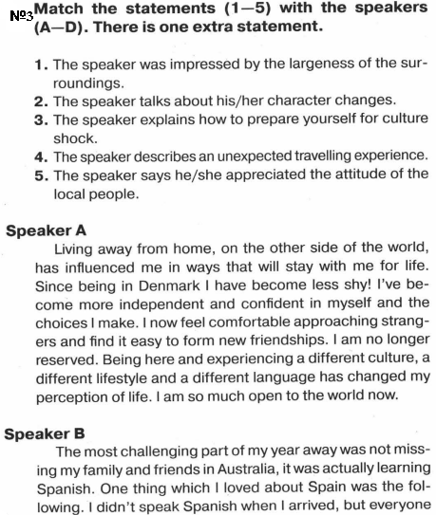
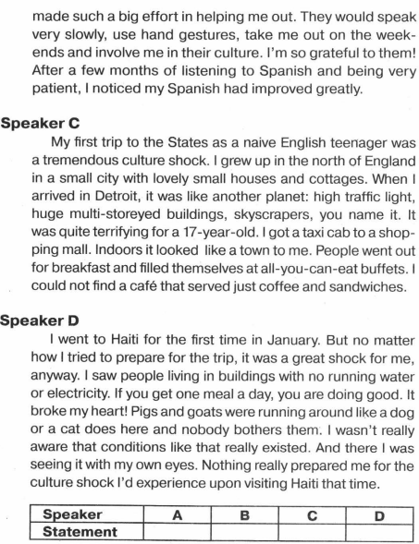

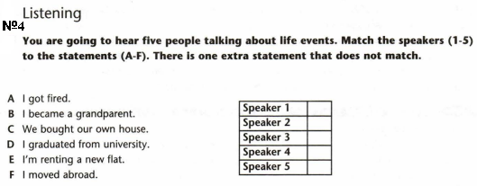

№5* Describe the picture:



№5* Describe the picture:


Критерии оценивания:
96-100% выполнения работы – оценка «отлично»
75-95% выполнения работы – оценка «хорошо»
50-74% выполнения работы – оценка «удовлетворительно»
Меньше 50% выполнения работы – оценка «неудовлетворительно»

